XCRAM
Data Design Document

Submitted to:

Asst. Prof. Ma. Rowena C. Solamo
Faculty Member
Department of Computer Science
College of Engineering
University of the Philippines, Diliman

Submitted by:
Submitted by:
Agluba, Gerry Jr. P.
Go, Sharleen Joy Y.
Silverio, Robelle C.

In partial fulfillment of Academic Requirements
for the course
CS 191 Software Engineering I
of the
1st Semester, AY 2016-2017

Revision Control

History Revision:
Revision Date | Person Responsible | Version  Number | Modification
11/18/16 | Gerry P. Agluba | 1.0 | Initial Document; Make csv format for data files: Schedules, TimeBlocks, Tasks, SaveScheduleList, and TaskPriorityQueue

Data Design:

[In this section, place here the class diagram].

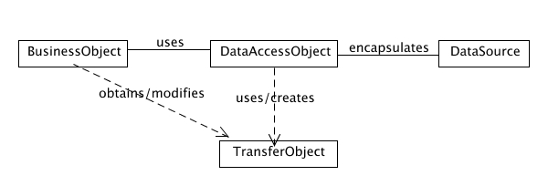

Data Access Object (DAO) Classes:
Class Name | Description

TransferObject Classes:
Class Name | Description

List of Data Source:

Data Source Name: Schedules.csv
Description: Schedule.csv contains all schedules

Sample Source File:
Format: <scheduleReferenceNumber>::<name>:<nextScheduleReferenceNumber>:
1::MYDailySchedule:8:
3::WeekendSchedule:-1:
0::!:1:

Data Source Name: TimeBlocks.csv
Description: TImeBlock.csv contains data involving Timeblocks and the Schedule they currently residing in.

Sample Source File:
Format: <timeblockid> ::<startTime> :<endTime>:<duration>:<taskId>:<prevTimeblockId>:<nextTimeBlock> :<scheduleReferenceNumber:
1::1130:1330:0200:-1:6:9:3:
6::0900:1130:0230:17:-1:1:3:
9::1330:2400:1070:18:1:-1:3:

Data Source Name: Tasks.csv
Description: Tasks.csv contains all data involving a task

Sample Source File:
Format: <taksId> :: <taskname> : <type> :<duration>:<mustart>:<mustend>:<priority>: <ScheduleReferenceNumber>:
6::CS191Class:0:0200:1130:1330:-1:3:
7::CS131Class:0:0300:430:1730:-1:3:
8::Review:1:0500:1830:2330:2:3:
13::Review:1:0200:1130:1330:1:7:

Data Source Name: PriorityQueue.csv
Description: PriorityQueue.csv is a queue of tasks kicked by the scheduler, either to be rescheduled or to be vanished permanently from the current schedule.

Sample Source File:
Format: <taksId> ::<taskname>:<priorityKey>

13::Go shopping:8
14::exercise: 11
18::date:5

